|  |  |
| --- | --- |
|  | **DOKUZ EYLÜL UNIVERSITY**  **ENGINEERING FACULTY**  **DEPT. OF COMPUTER ENGINEERING** |

# BLOOD DONATION SYSTEM

# CME 3201 Database Management Systems

# Term Project Report

Phase 1

2019-2020 FALL

2015510065 Nazlıcan VARIŞLI

2015510051 Utku OVALI

## Introduction

The main aim of developing this system is to provide blood to the people who are in need of blood. The number of persons who are in need of blood are increasing in large number day by day. Using this system user can search blood group available in the city and he can also get contact number of the donor who has the same blood group he needs. In order to help people who are in need of blood, this Online Blood Bank management system can be used effectively for getting the details of available blood groups and user can also get contact number of the blood donors having the same blood group and within the same city. So if the blood group is not available in the blood bank user can request the donor to donate the blood to him and save someone life. Using this bank management system people can register himself or herself who want to donate blood. To register in the system they have to enter their contact information like address mobile number etc.  
  
This blood bank management system is an online website so it is easily available to everyone. When a person want to donate blood he have to register to the system. Donor registration is very easy, to get register to the system he have to fill up registration form. After submitting the registration form he can create username and password. Donor have to give information like blood group, contact details etc. donor can also change his account information when he wants using his username and password.  
  
Using this blood bank system people can search blood group available which they are needed. They check it online using our blood bank management website. If in case blood group is not available in blood bank they can also get contact numbers of the persons who has the same blood group he is need. And he can request the person to donate the blood for saving someone life. Our system also allow user to search online the person who have the same blood group he needs and if he find the If he find a donor in his city then we give him all details of the donor, if he doesn’t find any donor then he is given the contact numbers and addresses of the Life Saving Contact Persons for big cities.

## Overview

The proposed Blood Bank management system helps the people who are in need of a blood by giving them all details of blood group availability or regarding the donors with the same blood group.

Online Blood Bank management system is to provide services for the people who are in need of blood by getting help from the donors who are interested in donating blood for the people. There are seven main modules in this system.

**Admin**

**Donors**

**Donor Registration**

**Modifying Donor Information**

**Acceptors  
  
Donor Search**

**Life Saving Contacts**

**[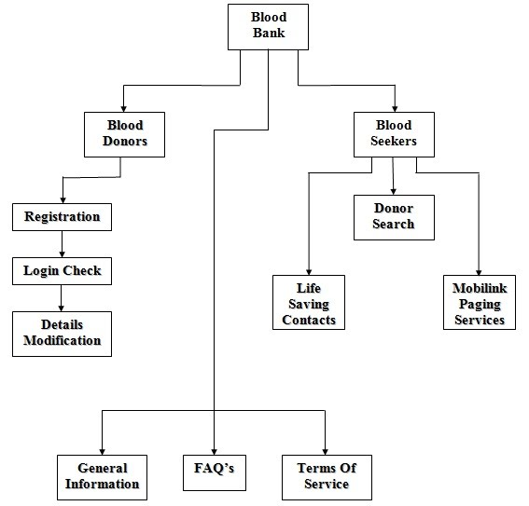](https://sites.google.com/site/ignoubcafinalyearprojects/project-report/blood-bank-management-system-project-report/Blood%20bank%20management%20system%20-%20Flow%20Diagram.jpg?attredirects=0)**

## Assumptions/Constraints/Risks

### Assumptions

Operating System         :    Windows 10

Web Browser               :     Internet Explorer, Chrome, Mozilla

Designing Tool              :      HTML

Client Side Scripting      :     Java

Backend                       :     MS SQL server

### Constraints

Donors must be **18-65** years old.

You must weigh at least **50 kg**.

### Risks

A visual design that has a confusing and unattractive layout that is rejected by clients.

A security design for a website that has vulnerabilities.

## Software Architecture

Instructions: Show your details of software architecture. Do you use n-tier architecture? How did you design it in your project? You may draw software architecture diagram (It depicts how a typical software system might interact with its users, external systems, data sources, and services.). How did you provide a connection between database and frontend? Give details about your software architecture.